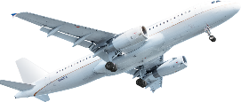
Emmas Trips

ADD YOUR LOGO TO TOP RIGHT

I hope you are all looking forward to the holiday to *******. Please can you look at the cost spreadsheet and proposed day trips below. Please let me know which of the following options you would prefer.
I look forward to hearing your opinions.
Best Wishes
SIGN LETTER WITH YOUR NAME
Elaine

COPY OF SPREADSHEET FIGURES ADDED HERE

