Add a Cover Page in Word
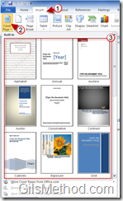
1. Click on the Insert tab in the Office Ribbon.
2. Click on the Cover Page button in the Pages group.
3. Choose a Cover Page template from the list.
Note: When you insert the cover page, it will become the first page of the document you are working on.
3. Add information to cover page. Use the pre-formatted text boxed for best results.
The transformed cover page…much better.
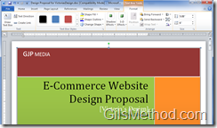
You can customize the cover page by using the tools available in the Office Ribbon.
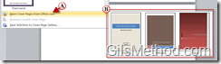
A. The available cover page templates not enough? You can always use the More Cover pages from Office.com link to access (B) more templates.

Cover Pages Available
